Dear guests,

We are happy and excited to have you. Lets make it a once-in-a-lifetime experience, full of color, tradition, and joy.

Here are some helpful tips and guide to make it a memorable experience:

- Visa and travel arrangements: If you're not an Indian citizen, you'll need a visa to enter India. Make sure to apply for your visa well in advance of your travel dates. Also, be sure to book your flights and accommodation in Mumbai in advance to avoid any last-minute hassle. Please attached the invitation card with your visa application for a faster process.

- Accommodation: Your hotel has been booked for 26th and 27th June. It shall be Hotel Fariyas or Hotel Trident, Nariman Point. Details will be provided on arrival

- Transportation:
  - Please advice your flight/train/bus particulars in the form below, arranging for your airport pick up and drop to be arranged. This will be arranged by us.
  - Your transportation to and fro to the venues will be arranged by us.

- Food:
  - There will be guests from all over the world and accordingly we have tried to cater to everyones needs. Based on the event, you will find various option like vegetarian, vegan, non vegetarian, Indian sweets, Chinese, and Western dishes. Traditionally Indian cooking uses a lot of butter, so please throw the diet out of the window. We show our love by feeding you, so get ready to enjoy a variety of scrumptious dishes.
  - Dietary requirements/Allergies – Please do list your dietary requirements/allergies when your RSVP on the link below. We cannot guarantee, but we will try and take care of those requirements.

- Schedule and Events
There are 5 functions -
  - Event: Mehendi (Henna) followed by Lunch
    - Date and time: 26th June, 2023, 12 PM onrwards
    - Venue: Hotel Trident, Nariman Point
    - Dress Code: Festive (colorful)
    - Sample Images:

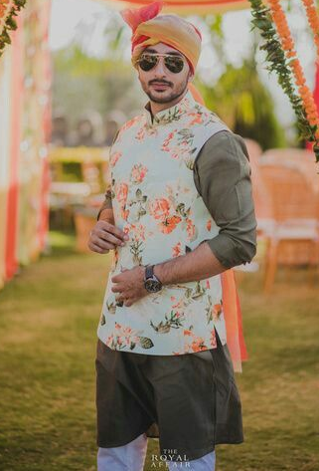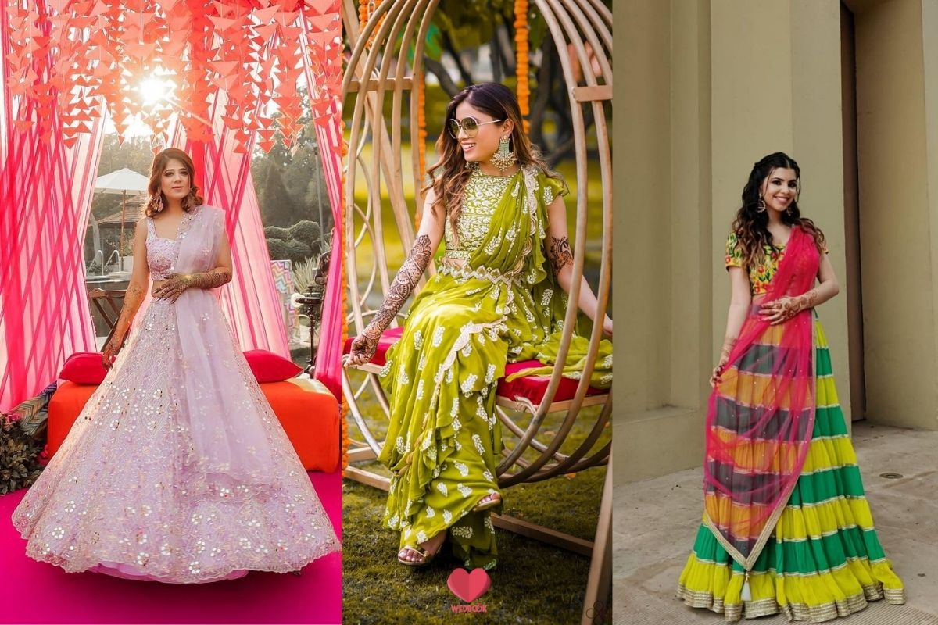
    - Store Recommendations:
- For Men- FabIndia, Manyavar, Aishwarya Design Studio
- For Women- Biba, Manyawar Mohey, Aishwarya Design Studio
- For custom make you can call Trupti designer (for both men and women). Contact info- +91 93267 83123
    - About the event: The Mehendi function is a pre-wedding ceremony that is commonly held in Indian weddings. It is a traditional event where largely the female family members and friends gather to apply henna designs on their hands and feet. The henna is usually applied in intricate and elaborate designs, often featuring floral and paisley patterns. The application of henna is considered a symbol of good luck and is believed to bring happiness and prosperity to the bride and her family. During the Mehendi function, the atmosphere is lively and festive, with music and delicious food.

  - Event: Ring Ceremony, Sangeet and Cocktail
    - Date and time: 26th June, 2023, 7 PM Onwards
    - Venue: Opa Kipos, Worli
    - Dress Code: Glitter and Glam – Western or Indian
    - Sample Images:

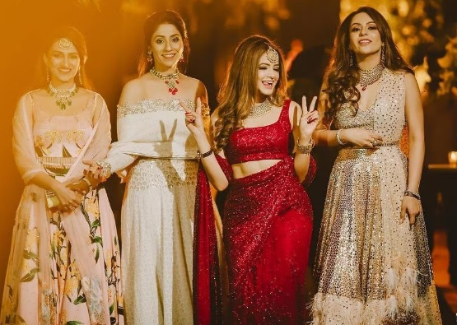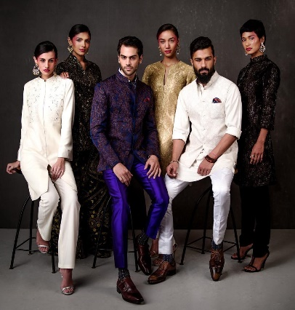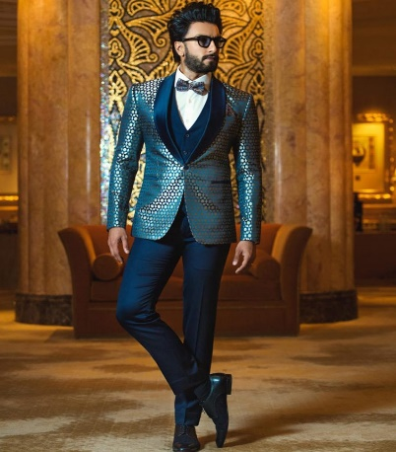

    - Store Recommendations:
- For Men- FabIndia, Manyavar, Aishwarya Design Studio
- For Women- Biba, Manyawar Mohey, Aishwarya Design Studio
- For custom make you can call Trupti designer (for both men and women). Contact info- +91 93267 83123
    - About the event: The ring ceremony, also known as the engagement ceremony, is a pre-wedding event that is commonly held in Indian weddings. It is a formal announcement of the couple's intention to marry and a symbol of their commitment to each other. During the ring ceremony, the couple exchanges rings, which are usually made of gold or other precious metals and are adorned with diamonds or other precious stones. The rings are placed on the couple's left ring finger, which is believed to be connected to the heart by a vein, according to Indian tradition. The ring ceremony is usually attended by close family members and friends of the couple.

  - Event: Haldi
    - Date and time: 27th June, 2023, 11 AM onwards
    - Venue: Crystal Ballroom, Hotel Taj Mahal Palace
    - Dress Code: Yellow or use of yellow
    - Sample Images:
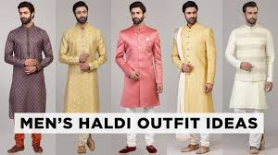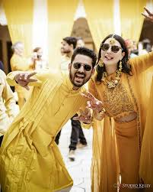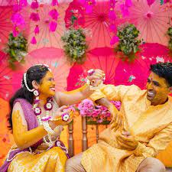

    - Store Recommendations:
    - About the event: The Haldi function is a pre-wedding ceremony that is commonly held in Indian weddings. It is a traditional event where turmeric paste is applied to the bride and groom's skin to purify and beautify them before the wedding. During the Haldi function, a paste made from turmeric, sandalwood powder, and other natural ingredients is applied to the bride and groom's face, arms, and legs. The paste is believed to have cleansing and healing properties for the couple.

  - Event: Baraat (Marriage Procession)
    - Date and time: 27th June, 2023, 3 PM onwards
    - Venue: We will start near Hotel Regent, just next to Hotel Taj Mahal Palace
    - Dress Code: Royal Indian Finery (We will arrange for the headgear/Safaas)
    - Sample Images:

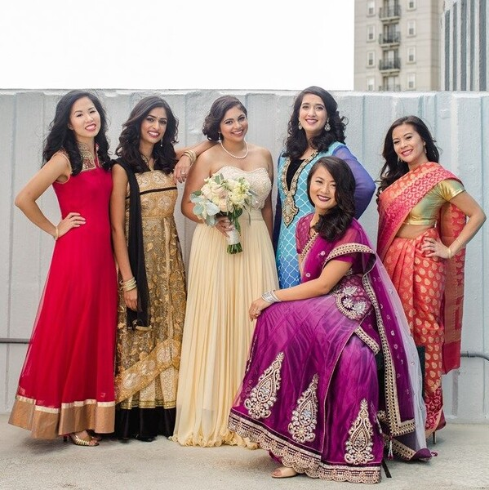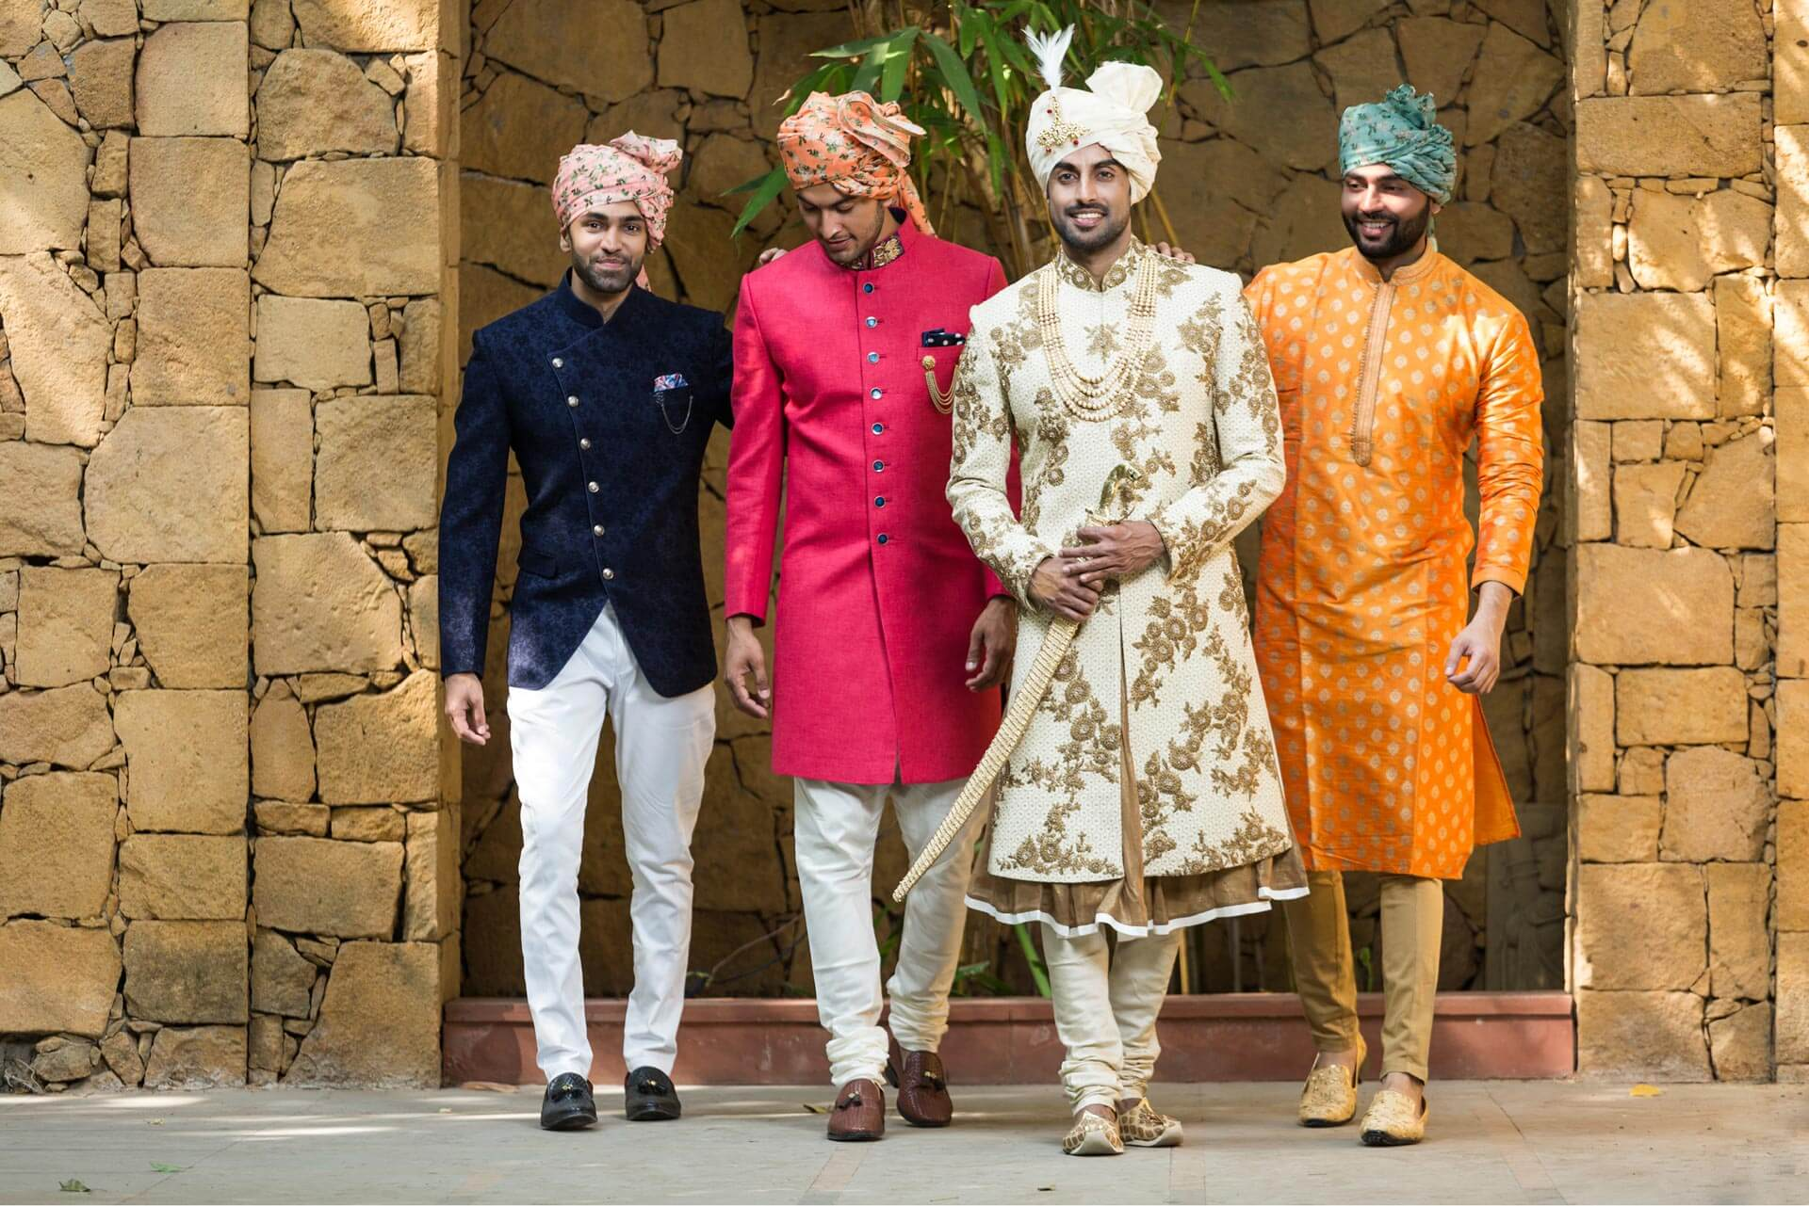

    - Store Recommendations
- For Men- FabIndia, Manyavar, Aishwarya Design Studio
- For Women- Biba, Manyawar Mohey, Aishwarya Design Studio
- For custom make you can call Trupti designer (for both men and women). Contact info- +91 93267 83123
    - About the event: A Baraat is a traditional Indian wedding procession that involves the groom and his family and friends traveling to the wedding venue on horseback or in a decorated car. The Baraat usually started at the groom's home, where he and his family members and friends gather to start the procession. As the Baraat approaches the wedding venue, the groom's family and friends dance to music played by a band or a DJ, and they may also carry colorful decorations. At the wedding venue, the Baraat is traditionally welcomed by the bride's family, who may perform aarti (a Hindu ritual of welcoming) and offer the groom and his family sweets and flowers. The Baraat is typically a loud and boisterous affair, with a lot of singing, dancing, and merriment. So get ready to start dancing on the streets!

  - Event: Pheras and Reception
    - Date and time: 27th June, 2023, 7 PM onwards
    - Venue: Crystal Ballroom, Hotel Taj Mahal Palace
    - Dress Code: Royal Indian Finery
    - Samples Images:
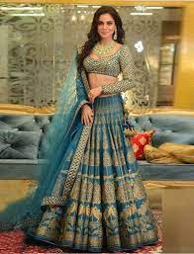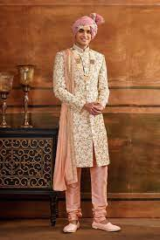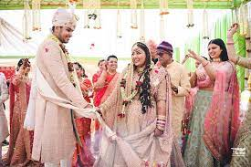
    - Store Recommendations:
- For Men- FabIndia, Manyavar, Aishwarya Design Studio
- For Women- Biba, Manyawar Mohey, Aishwarya Design Studio
- For custom make you can call Trupti designer (for both men and women). Contact info- +91 93267 83123
    - About the event: Pheras are a significant ritual in Hindu weddings, which involves the bride and groom walking around the sacred fire seven times, while making a series of vows to each other. This is the actual wedding ceremony.
Post the ceremony, will be the wedding receptions to greet the couple.

- Some more details if required –
  - Dress code: Indian weddings are typically formal events, and the dress code for the wedding ceremonies is usually traditional Indian attire. For women, a saree or a salwar kameez is appropriate, while men typically wear a kurta pajama or a sherwani. You may want to consider purchasing or renting these outfits before you arrive in Mumbai.
  - About the functions: Indian weddings are multi-event affair, and it's common for ceremonies to last for several hours. Make sure to arrive on time, and be prepared to spend a significant amount of time at the wedding venue. The exact schedule of events have been provided, but you can expect to attend a variety of ceremonies, including the engagement, the sangeet (a musical evening), the mehndi (a henna ceremony), and the wedding ceremony itself.
  - Etiquette and customs: Indian weddings are steeped in tradition and culture, and it's important to respect these customs as a guest. You may also be invited to participate in certain rituals or ceremonies, such as applying henna or exchanging garlands with the couple. Be respectful and open-minded, and don't be afraid to ask questions if you're unsure about anything.
  - Food and drink: Indian weddings are known for their delicious food, which typically includes a wide range of vegetarian and non-vegetarian dishes. Be prepared to try new flavors and spices, and don't be afraid to ask for recommendations if you're unsure about what to try. Alcohol will be served at some functions and not all of them, , depending on the traditions.
  - Safety and security: Mumbai is a bustling city, and is extremely safe compared to any part of the world. However, it's important to take appropriate safety precautions during your visit. Make sure to keep your valuables secure, and be aware of your surroundings at all times.
  - Weather: June is usually when the monsoon starts in Mumbai. So it may rain, it may not, be ready with jackets and umbrellas just in case.
  - Additional Stay – In case you would like to stay for additional days before or after the event, we have a tie up with Hotel Sea Princess, Juhu. They have offered us a flat tariff of Rs.7500+Taxes or approx. US$104. You can Book it online on http://www.seaprincess.com and use the Promo Code: BULLET2023. We would suggest this, as its right in front of the beach, and next to our house, so we can spend more time together. Alternatively, if you would like to stay in South Mumbai, we have a special tariff with Trident, Nariman Point @ Rs. 10500+taxes or approx. US 150. You can email Behzad.Tarapore@oberoigroup.com.
  - Additional travel – In case, you would like to spend some more time in India, or around India, we have tied up with a travel agent. You can contact Suitcase Diaries - Joy Bajaj info@suitcasediaries.in or joy@suitcasediaries.in with the code Bullet
Overall, we would like you to make this into a a grand wedding and a wonderful experience, full of color, music, and joy.

For anymore questions, please feel free to respond to this whatsapp or you can email, thementalwedding@gmail.com

